
ذ
REPUBLIC OF YEMEN
SANA'A UNIVERSITY
FACULTY OF ENGINEERING
MECHATRONICS ENGINEERING DEPARTMENT



Non stop heron’s fountain

Done by:
Hassan Moqbel Morshed Ghaleb_ 202274198
Ali Mohammed Ahmed AL_sowde_202274213
System(Parallel)
Supervised by:
prof. Abdul Malik
ENG.Housam AL_Khatib

contact:-

Abstract................... 1
Objectives………….. ……… 2
Introduction……………………….. 3
Theory........................................ 4
Methodology………………………...... …... 5
Experiment...... ……………………….... 6
Procedure……………………………… 7
Results……………………………8
Current Applications.. 9
Discusion……………… 10
Conculosio……. 11
References……………

1_ Abstract:-
Non stop heron’s fountain is a small-scale project that operates continuously and is based on the Heron’s formula in physics. It consists of three interconnected basins with thin pipes, and it relies on the flow of water due to atmospheric pressure inside the pipes. The potential energy of water is converted into kinetic energy, which creates a continuous flow of water in the pipes and basins. The project is designed to be eco-friendly and easy to install and use. It can be used as a decorative item in a home or garden and is highly customizable and adjustable to fit any size or location. The project is a good example of applying scientific principles to create a useful and aesthetically pleasing item.

2_Objectives:-
The objective of Non stop heron’s fountain is to create a small-scale project that operates continuously and is environmentally friendly. The project aims to apply scientific principles, specifically Heron’s formula in physics, to create a useful and aesthetically pleasing item. The fountain is designed to be easy to install and use, making it accessible to a wide range of people. Its customization options also make it suitable for various locations and sizes. The project can be used as a decorative item in a home or garden, adding an attractive touch to any space. Overall, the objective of Non stop heron’s fountain is to provide an example of how scientific principles can be applied to create a practical and beautiful project.

3_Introduction:-
Non-stop Heron’s Fountain is a type of fountain that demonstrates the principles of fluid dynamics and the laws of physics, specifically the law of conservation of energy. It is named after Heron of Alexandria, a Greek mathematician and engineer who described the fountain in his work “Pneumatica” in the first century AD.

The Non-stop Heron’s Fountain works by using the pressure of water to create a continuous flow of water. The fountain consists of three chambers, each with a small hole at the bottom. The first chamber is filled with water, and as the water flows out of the first hole, it creates a pressure differential that draws water from the second chamber into the first chamber. As the water level in the first chamber rises, it eventually reaches the second hole, which creates another pressure differential that draws water from the third chamber into the second chamber. This process continues in a loop, with water flowing from the third chamber into the second, and from the second into the first, creating a continuous flow of water.

The Non-stop Heron’s Fountain is a popular science experiment and is often used as a teaching tool to demonstrate the principles of fluid dynamics and the laws of physics. It is a simple and fascinating demonstration that showcases the beauty and complexity of the natural world.

4_Theory:-
Non stop heron’s fountain is based on the principle of converting the potential energy of water into kinetic energy, through the flow of water in pipes and basins. This fountain is characterized by working continuously without interruption, and it uses the Heron’s formula in physics to create a continuous flow of water in pipes.

The general theory of Non stop heron’s fountain is based on the laws of physics that govern the flow of water, atmospheric pressure, and kinetic energy. The system depends on the height of the first basin and the atmospheric pressure inside the pipes, which causes the water to move in the pipes continuously and without interruption.

Heron’s formula in physics relies on determining the half-perimeter of a triangle and the lengths of its sides, and it is used to calculate the area of a triangle. In the case of Non stop heron’s fountain, this formula is used to calculate the flow of water in pipes, where the lengths of pipes and basins, as well as the heights, are used to determine the required flow rate to move the water continuously.

In general, Non stop heron’s fountain relies on converting the potential energy of water into kinetic energy without using any external power sources, making it an eco-friendly project that is easy to install and use. It can be used as a beautiful decoration in a home or garden, and it is highly customizable and adjustable to fit any size or location.
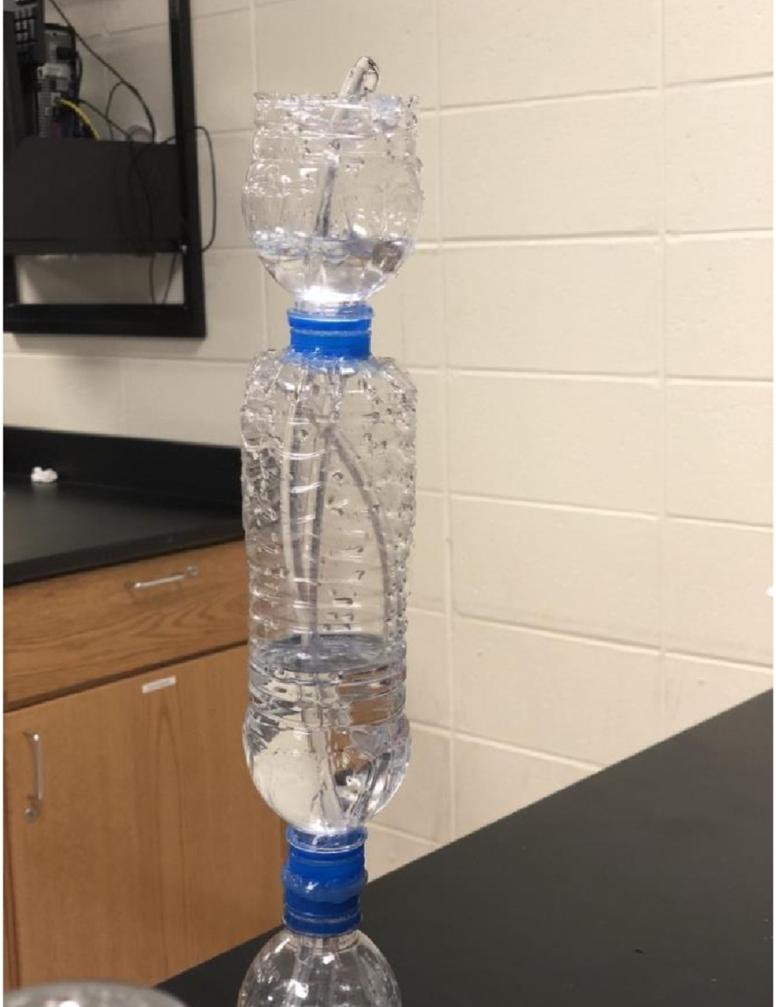

_Heron’s fountain, invented by Heron of Alexandria and its corresponding fluid dynamic principles.

5_Methodology:-

The Non-stop Heron’s Fountain can be constructed using simple materials, and the methodology involves the following steps:

_First, Gather the materials: The materials needed for constructing the fountain include three containers of different sizes, such as plastic bottles or jars, a small tube, and water.

_Second, Prepare the containers: The first container is filled with water, and a small hole is made at the bottom of the container. The second container, which is smaller in size, is placed inside the first container, and a small hole is made at the bottom of this container as well. The third container, which is even smaller than the second container, is placed inside the second container, and a small hole is made at the bottom of this container too.

_Thired, Connect the containers: A small tube is inserted into the hole at the bottom of the third container, and the other end of the tube is inserted into the second container through the hole at the bottom. Another tube is inserted into the hole at the bottom of the second container, and the other end of the tube is inserted into the first container through the hole at the bottom.

_Fourth, Test the fountain: Once all the containers are connected, the first container is filled with water. As the water flows out of the first hole, it creates a pressure differential that draws water from the second container into the first container. As the water level in the first container rises, it eventually reaches the second hole, which creates another pressure differential that draws water fromthe third container into the second container. This process continues in a loop, creating a continuous flow of water.

_Fifth, Adjust the flow: The flow rate of the fountain can be adjusted by adjusting the size of the holes in the containers or the length of the tubes. The flow rate can also be affected by the height of the containers and the amount of water in them.

_Sexth, Experiment with variations: Once the fountain is working, it can be used to experiment with variations such as adding food coloring to the water or changing the size or shape of the containers.
_In the pictures below 👇🏼is a sample of the shape of the circuit and how it works non stop heron’s fountain.
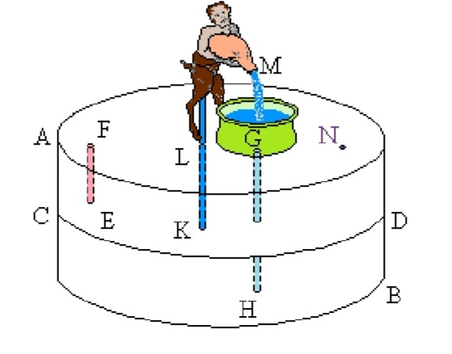
_Heron’s Fountain, based on the original drawing.

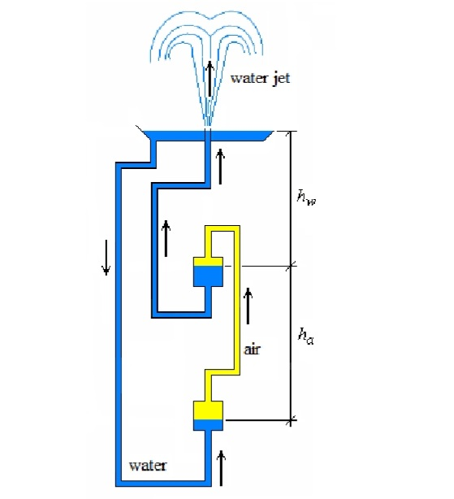
_Hydraulic circuit of Heron’s Fountain.

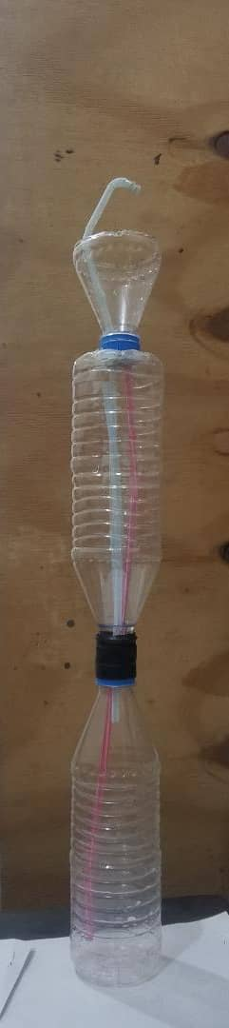 | 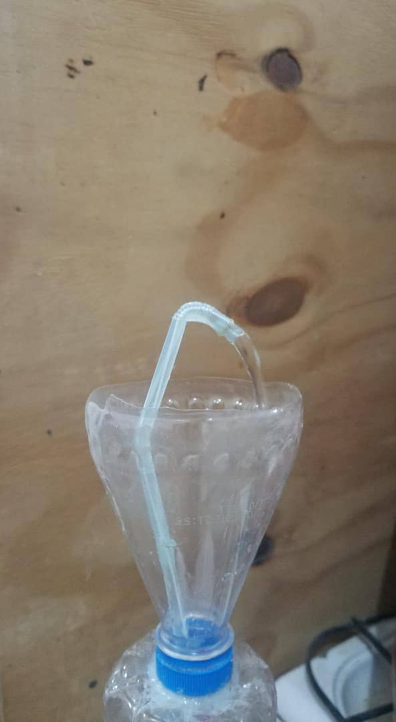
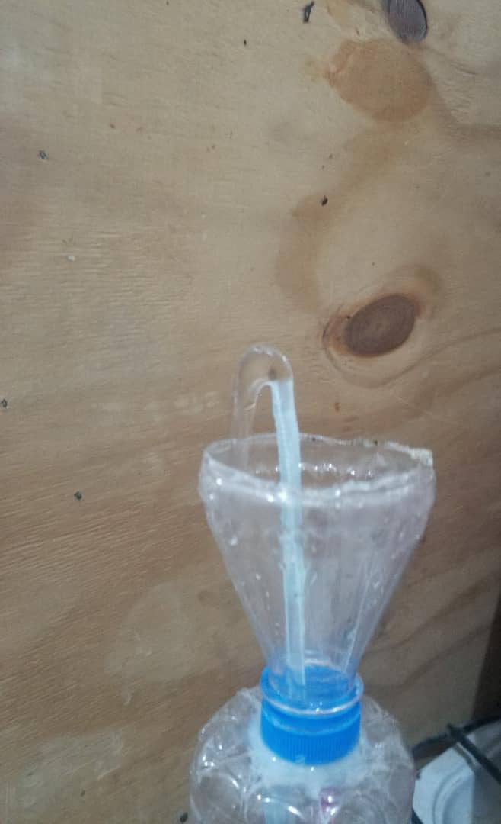 | 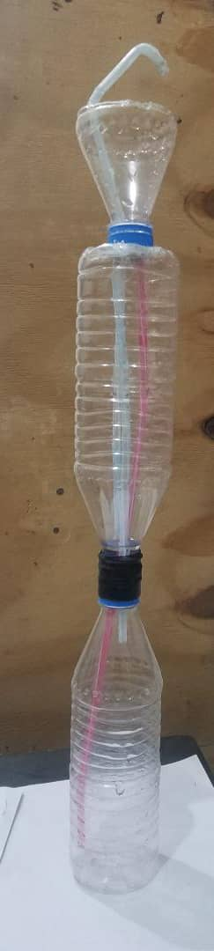

6_Experiment:-

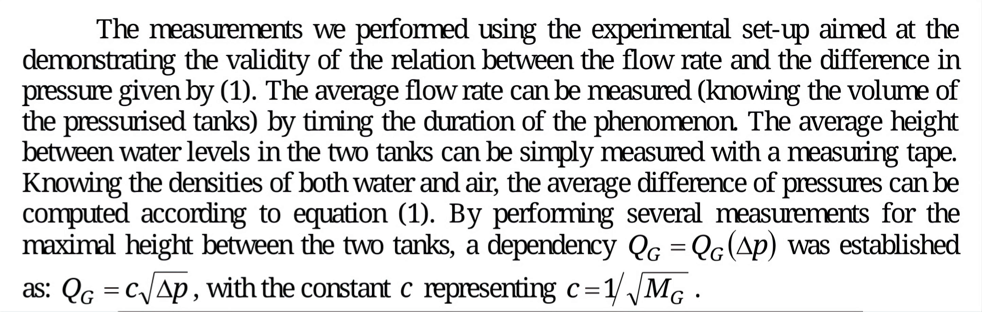
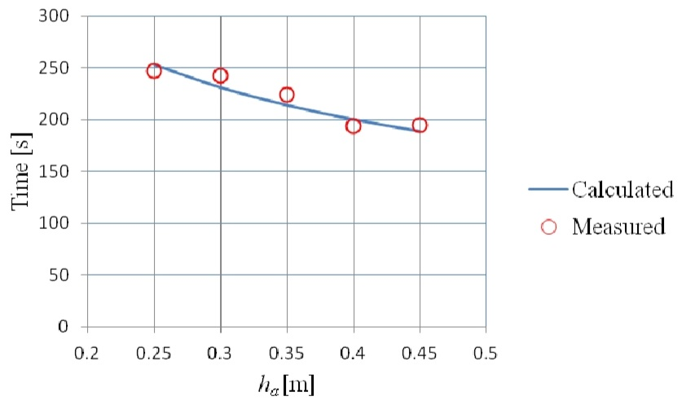
_Calculated and measured values for the duration
of the phenomenon the when working like Heron’s
Fountain at different heights between the two closed tanks.

The value of the constant was then used to compute the flow rate and consequently the duration of the phenomenon for smaller heights. Measurements of the duration of the phenomenon at different heights where then performed and the results were compared with the calculated values. (see in the above ☝🏽example graphically). The match between calculated and measured values is very good.

7_Procedure:-
#_The non-stop Heron’s fountain works by utilizing the force of gravity to create a continuous flow of water. As water flows out of the first basin, it creates a difference in pressure with the second basin inside it, which then pulls water from the second basin to the first basin. This process repeats, causing a continuous flow of water.

The pressure in the fountain helps push water through pipes, with the difference in pressure between the two basins causing the water to move. The surface tension of the water helps to keep it from leaking out of the openings in the barriers, allowing for a continuous flow of water through the pipes and barriers.

##_Materials:
- Three containers of different sizes (such as plastic bottles or jars)
- Small tube
- Water

Construction:
1. Fill the largest container with water and make a small hole at the bottom of the container.
2. Insert the second container, which is smaller in size, inside the largest container and make a small hole at the bottom of this container as well.
3. Insert the third container, which is even smaller than the second container, inside the second container and make a small hole at the bottom of this container too.
4. Connect the small tube to the bottom of the third container, and then connect the other end of the tube to the bottom of the second container.
5. Connect another tube to the bottom of the second container, and then connect the other end of the tube to the bottom of the first container.
6. Adjust the size of the holes or the length of the tubes to control the flow rate of the fountain.

###_Operation:
1. Fill the largest container with water.
2. Water will flow out of the first hole and create a pressure differential that draws water from the second container into the first container.
3. As the water level in the first container rises, it eventually reaches the second hole, which creates another pressure differential that draws water from the third container into the second container.
4. This process continues in a loop, with water flowing from the thirdcontainer into the second, and from the second into the first, creating a continuous flow of water.

8_ Results:-
Non stop heron’s fountain is a unique and environmentally friendly project that operates continuously using the principles of physics. The project consists of three interconnected basins and thin pipes, and the Heron’s formula in physics is used to calculate the flow rate of water in the pipes. The potential energy of water is converted into kinetic energy, creating a continuous flow of water in the pipes and basins. The project is designed to be easy to install and use, making it suitable for various locations and sizes. It can also be used as a beautiful decoration in a home or garden, adding an attractive touch to any space. Non stop heron’s fountain is an excellent example of applying scientific principles to create a practical and beautiful decoration. The project combines science and art to create a unique and eco-friendly decoration. Overall, Non stop heron’s fountain is a creative and practical project that can be used anywhere to add an artistic and aesthetic touch while also protecting the environment and relying on important scientific principles.

9_Current Applications:-
Fountains can be found nearly everywhere in everyday life, from parks and lawns to smaller scale ones like water fountains in buildings. Such fountains serve a multitude of purposes, ranging from providing a source of water to aesthetic designs and entertainment such as the impressive water shows all over the world. Similar hydraulic concepts can be discovered in hydraulic car brakes, certain exercise machines, and more.

10_Discusion:-
_Non stop heron’s fountain is a fascinating and innovative project that uses the principles of physics to create an aesthetically pleasing and functional decorative item. The project is based on the Heron’s formula in physics, which is used to calculate the flow rate of water in pipes. By converting potential energy into kinetic energy, the project creates a continuous flow of water in the interconnected basins and pipes, producing a calming and soothing environment.

One of the significant advantages of the Non stop heron’s fountain is its sustainability. The project requires no electricity to operate, making it a cost-effective and eco-friendly decorative item. Additionally, the project’s easy installation and use make it accessible to people of all ages and backgrounds.

Another advantage of the Non stop heron’s fountain is its adaptability. The project can be adjusted and customized to fit different sizes and locations, making it a versatile and flexible decorative item. This makes it ideal for use in a variety of settings, including residential and commercial spaces.

From a design perspective, Non stop heron’s fountain is an excellent example of how science and art can be combined to create a visually stunning decorative item. The continuous flow of water in the interconnected basins and pipes creates a mesmerizing and elegant display that adds a touch of sophistication and tranquility to any space.

In conclusion, Non stop heron’s fountain is a practical, aesthetically pleasing, and eco-friendly project that showcases the potential of science and art to create innovative and sustainable decorative items.The project’s ability to convert potential energy into kinetic energy without relying on electricity makes it a great example of how to use natural resources in a sustainable and environmentally friendly way. The project’s easy installation and customization options make it accessible to a wide range of people, and its elegant design adds an artistic and calming touch to any space. Overall, Non stop heron’s fountain is a creative and practical project that combines science and art to create an eco-friendly and visually stunning decorative item.

11_ Conculosion:-
_In conclusion, Non stop heron’s fountain is an innovative and eco-friendly project that uses the principles of physics to create a beautiful and functional decorative item. The project’s ability to convert potential energy into kinetic energy without relying on electricity makes it a sustainable and cost-effective decorative item. The project’s easy installation and customization options make it accessible to a wide range of people, and its elegant design adds an artistic and calming touch to any space. Non stop heron’s fountain is an excellent example of how science and art can be combined to create innovative and sustainable decorative items that provide both beauty and functionality. Overall, Non stop heron’s fountain is a creative and practical project that showcases the potential of science and art to create eco-friendly and visually stunning decorative items.

_Reference:-
References are not books, but programs such as Google and YouTube.

